UPLB MUNI: A MOBILE MENTAL HEALTH APPLICATION FOR UPLB STUDENTS WITH SENTIMENT ANALYSIS AND CHAT FEATURES

A Special Problem Presented to the Faculty

Of the Institute of Computer Science

University of the Philippines

Los Baños

In Partial Fulfillment of the Requirements for the Degree of

**Bachelor of Science in Computer Science**

By:

**Skye Bernadette Rafaelle B. Santos**

**JUNE, 2024**

The Faculty of the Institute of Computer Science

University of the Philippines Los Baños

Accepts this Special Problem Entitled

UPLB MUNI: A MOBILE MENTAL HEALTH APPLICATION FOR UPLB STUDENTS WITH SENTIMENT ANALYSIS AND CHAT FEATURES

Submitted by:

**Skye Bernadette Rafaelle B. Santos**

In Partial Fulfillment of the Requirements for the Degree of

Bachelor of Science in Computer Science

**ASST. PROF. MYLAH RYSTIE U. ANACLETO**

Adviser

Date Signed

**ASSOC. PROF. MARIA ART ANTONETTE D. CLARIÑO**

Director

Institute of Computer Science

University of the Philippines Los Baños

Date Signed

**ACKNOWLEDGEMENT**

I would like to express my deepest gratitude to those who have supported and guided me throughout the journey of completing this special problem, titled “UPLB Muni: A Mobile Mental Health Application for UPLB Students with Sentiment Analysis and Chat Features”.

First and foremost, I would like to thank my thesis advisor, **Prof. Mylah Rystie U. Anacleto,** for her constant guidance, insightful feedback, and continuous encouragement. Her expertise and dedication have been instrumental in helping me finish this final requirement for my degree. I am especially grateful for her nurturing guidance and unwavering support, which have been akin to a motherly influence throughout this journey.

To my **highschool friends, Laizsa, JJ, Patrishia and Aina,** for their unwavering friendship, constant encouragement, and for always believing in my potential. Your consistent messages, even without your knowing, provided immense support during stressful periods. Thank you for always being there, cheering me on, and reminding me that I can do anything.

To **everyone I encountered in ICS,** you have all contributed in making this research a reality.

To **Kyro,** for his unwavering patience and understanding, especially when I was in turmoil with my technical needs. Your encouragement and belief in me have been a cornerstone of my strength. Thank you for being my constant source of support and for standing by me through every challenge and triumph.

Finally, I am deeply thankful to **my family** for their unwavering support, patience, and love. Thank you to **my parents** for never giving up on me and for doing their hardest to give me everything I ever needed and making sure I was always comfortable enough to finish this milestone without hardship and distractions. To my sister, **Rainbow,** for always showing me that I am an older sister to be proud of and capable of facing all the challenges thrown my way. To my **grandparents,** for always being there to shower me with unending love and constant praises no matter how small my accomplishments were. You are the pillars of my strength, the foundation upon which I have built my dreams. Your sacrifices, guidance, and unwavering belief in me have made this journey possible.

Thank you **God** for all the guidance and prayers you have answered for me. I am nothing without You.

**TABLE OF CONTENTS**

**ABSTRACT 7**

**INTRODUCTION 8**

A. Background of the Study 8

B. Significance of the Study 10

C. Objectives of the Study 10

D. Scope and Limitations 11

**REVIEW OF RELATED LITERATURE 12**

A. Mental Health Applications 12

B. Demand in Mental Health Applications 13

C. Sentiment Analysis 14

D. React-Native 15

**MATERIALS AND METHODS 16**

A. Development Tools 16

B. Application Features 17

C. Classification of Users 18

D. Data Gathering and Testing 19

**RESULTS AND DISCUSSIONS 20**

**CONCLUSIONS AND FUTURE WORKS 23**

**RECOMMENDATIONS 24**

**BIBLIOGRAPHY 25**

**APPENDIX 28**

# **ABSTRACT**

The recent COVID-19 pandemic made numerous psychological and mental impacts on the youth today, especially those who were in the early years of their college life and education. Having to resort to online classes resulted in isolation during stressful days which left lasting effects on the mental well-being of many college students. In the University of the Philippines Los Banos, the Office of Counseling and Guidance is mainly concerned with the mental wellness of students in UPLB and empowering students to seek help when needed. In this study, a mobile application for mental health was developed to promote the mental wellness of the students through journaling, supportive messages from OCG and sending counselling requests through which they can communicate with OCG staff through chat. The study used the System Usability scale to test the application as well as a feedback section for more details and suggestions. 15 randomly selected UPLB students were asked to participate in the study, which produced a result of excellent SUS score on the application.

# **INTRODUCTION**

### Background of the Study

The recent onslaught of the COVID-19 pandemic has brought numerous negative impacts to many individuals across the globe. More than the physical damages it has left on the health of the society, its mental and psychological effects also made its mark on a significant number of people. According to Santomauro et al. (2021) , the increase of those with anxiety disorder reached 28% while those with depressive order reached 26% during the course of the worldwide pandemic. The spread of the virus forced many countries to declare indefinite lockdowns as measures and protocols to control the escalation which led to the isolation and disruption in the social life of many young adults (Wang et al., 2021). Without social support from outside forces and the added burden of financial difficulties that the pandemic caused, the mental health crisis in today’s generation worsened to a point of increasing worry (Hechanova-Alampay et al., 2022).

The prolonged period of isolation during the pandemic has left lasting impacts on the mental wellbeing of those part of the adolescent age, or more specifically those in Generation Z. They were devoid of the traditional college experience as their first two years of learning was done online and asynchronously.According to Akpinar (2021), the efficiency of the online learning approach is reliant on how learners adapt and interact with the system and the instructional strategies employed by instructors. However, despite its effectiveness in certain aspects, this mode of learning has brought increased stress and negative academic outcomes for college students.

The sudden switch to virtual learning not only disrupted their academic routines but also hindered their social interactions that were crucial to their personal development and emotional support. According to Copeland (2021), the absence of in-person connections and the constant barrage of pandemic-related issues took a significant toll on the resilience of college students. According to Labrague et al. (2021) findings, college students experienced a greater prevalence in loneliness and anxiety with the lockdown implemented during the pandemic. Such mental challenges experienced by students have affected them up to this day, almost a year after the pandemic has happened. With this, the need to address these delicate issues is an important responsibility that universities must take seriously.

In the Philippines, there is a significant lack of mental health services that can immediately attend to the needs of those who are suffering such mental health issues. According to World Health Organization (WHO) last 2018, only 5% of our healthcare expenditure is used for mental health care services. Only 7.76 hospital beds and 0.41 psychiatrists are appointed per 100,000 people in the country. With this, the need for more efficient mental health care services are increasing especially with the aftermath that the pandemic has caused. A recommendation from WHO includes mental health services that allow and encourage self-care interventions (Hechanova-Alampay et al., 2022). These self-intervention services have pushed for the many technological innovations that revealed a significant positive impact on this issue. Because of this, mobile applications were said to be a possible low-intensity intervention for those who have a less severe mental health issue.

In the University of the Philippines Los Baños, the Office of Counseling and Guidance can be utilized for the creation of the mobile application which aims to integrate activities and services that OCG provides for the students. This mobile application will also allow the students to have an accessible way to maintain and check their well-being and mental wellness at the palm of their hands.

### Significance of the Study

As the demand of mental health treatments and services increase in today's generation, the use and development of mobile mental health applications become an alternate method that can be used along with the traditional mental health monitoring methods (Becker, 2016). This mobile mHealth application would enable the students of UPLB to monitor their daily moods and fluctuating emotions through mobile journaling with integrated sentiment analysis. In addition, the OCG would also have a way to communicate with the students of the university through sending supportive messages through the application. Students would also be able to schedule counseling sessions through the application and can speak to available staff through the chat features of the application.

### Objectives of the Study

This study aims to develop a mobile application that promotes mental health of UPLB students through self-intervention and monitoring with integrated sentiment analysis for their journal entries as well as chat features. Specifically, it aims to achieve the following:

1. Create a mobile application that allows UPLB students to monitor their mental wellness through journaling and reflections with integrated sentiment analysis.
2. Provide the OCG a channel to constantly communicate with the student body through supportive messages.
3. Allow UPLB students to notify the OCG for counseling schedules and services.
4. Generate a report on overall wellness of the student body through collected data in the application.

### Scope and Limitations

The application will be developed during the 2nd Semester of the academic year 2023-2024, and is intended only to be used by the UPLB student body. The students would also have to manually book counselling services and will not be automated by the application. Since this will be utilizing a cloud-based service, an internet connection is needed when using the application.

### 

### 

# **REVIEW OF RELATED LITERATURE**

### Mental Health Applications

Mental health applications have garnered considerable attention as effective tools for improving overall well-being and quality of life. According to Lecome et al. (2020), mobile applications for mental health interventions have small to medium size effects with regards to anxiety, depression and stress. These mHealth applications can become a low-intensity intervention for those experiencing low severity of symptoms and can be considered as the initial approach to a stepped-care process. However, developers are urged, as highlighted by Thornton et al. (2018), to prioritize the incorporation of evidence-based information, including references and published research, and ensure clear developer affiliations during the design process of these types of applications.

A study by Hechanova-Alampay et al. (2022) contributed to this evidence-based information regarding mental health applications through the evaluation of a Philippine mobile mental health application named Lusog-Isip. While the application was not a means to replace clinical healthcare services for mental well-being, the findings show that it provided access to individuals on interventions to improve their mental health and other coping strategies as well as a list of mental health care providers in the country. Results also showed that the app was able to increase the overall well-being of the participants and improve their capability to cope with stressors in the environment through cognitive reappraisal, social support and relaxation/recreation. Regular mood tracking also enables a better understanding of one’s mental health state, empowering users to take proactive steps for improvement. In this context, self-awareness emerges as a crucial initial step in effectively managing mental health through innovative applications.

### Demand in Mental Health Applications

The demand for mental health applications has witnessed a significant surge with participants expressing widespread interest in mobile application therapy. This enthusiasm is rooted in the convenience, privacy, and affordability that such applications offer, making them accessible to a broad demographic. The relevance and cultural appropriateness of suggested cognitive-behavioral therapy strategies and advice further contribute to the appeal of these applications, as noted by the majority of users (Cap et al., 2019). Survey results highlight the prevalence of mobile health application usage among young people, who not only currently use these apps but also envision them as tools to promote their mental well-being (Gotzl et al., 2022). Quality, effectiveness, comprehensible content, and use case emerge as crucial considerations in this context (Gotzl et al., 2022). While respondents acknowledge that mental health apps cannot replace the therapeutic relationship between patients and providers, there is a belief that these apps could substitute for traditional face-to-face mental health services (Cap et al., 2019). This idea aligns with the previous research indicating that online mental health services enhance user confidence, offering anonymity during sessions. However, it is crucial to recognize that the initial comfort provided by online interactions does not diminish the effectiveness of face-to-face mental health services, which remain essential in addressing mental health problems (Sukmawati, 2019). As the popularity of mobile health solutions for mental healthcare rises and the stigma associated with mental health persists, there is a growing demand for user-centered design, seamless integration with ongoing care, and rigorous evaluation of impacts in workflows and clinical outcomes (Wang et al., 2021). In navigating this landscape, it becomes imperative to strike a balance between technological innovation and the nuanced complexities of mental healthcare.

### Sentiment Analysis

Sentiment analysis, commonly known as opinion mining, is a natural language processing (NLP) technique designed to discern the emotional tone conveyed in a text. It is widely employed by organizations to assess and classify opinions regarding a product, service, or concept. This methodology integrates data mining, machine learning (ML), artificial intelligence, and computational linguistics to extract sentiments and subjective details from text, determining whether the expressed feelings are positive, negative, or neutral (Barney, N.D.). It can discern the polarity, gauging the level of positivity or negativity, as well as identifying the subject and opinion holder within the text. This method is applied to analyze different components of the text, including entire documents or specific sections like paragraphs, sentences, or sub sentences.

In a study by Patacsil et al., 2015, the use of sentiment analysis as an innovative way to help in tracking the mood of a user resulted in a 91.50% accuracy. With this, sentiment analysis can be utilized in a way that identifies the mood and context of a person through their journal entries. The users would then be able to gain more self-awareness in the event that they are unable to distinctly classify their own emotions.

### React-Native

React Native is an open-source framework for building mobile applications using JavaScript and React. It was developed by Facebook and was first released in 2015. It allows developers to build mobile apps using the same principles and techniques used in React, a popular JavaScript library for building user interfaces (Digital Acceleration Company, 2023). This framework allows native-rendering of applications on both iOS and Android systems. It has gained popularity for its ability to streamline the development process and facilitate the creation of high-quality, cross-platform mobile apps.

### 

# **MATERIALS AND METHODS**

### Development Tools

The mobile application was developed using a personal laptop with the following specifications:

* Processor: Intel(R) Core(TM) i7-8750H CPU @ 2.20GHz 2.21 GHz
* RAM: 8 GB
* Memory: 1TB SSD
* Operating System: Windows 11 Home

The following technologies was used mainly in the mobile application development:

* React Native: a framework used for cross-platform application development
* Google Cloud Realtime Database

### Application Features

* 1. User Registration and Login: The app allows users to register using their UP mai as seen in Fig. 1, and once registered, are able to login and access the application's other features.
  2. Supportive Messages: The user receives supportive messages daily from the OCG staff procured from the database of messages (Fig. 2)
  3. Journaling: Users are also able to input journal entries in the application. Sentiment analysis will be used in these entries to identify its mood and tag these entries appropriately (green for positive, yellow for neutral and orange for negative moods).
  4. Chat Feature: OCG staff are able to chat directly to students who requested counseling and vice versa.
  5. Counseling Requests: Users are able to send counseling requests through the application.
  6. Add Supportive Messages: The staff from OCG can add supportive messages to the database, which is a collection of messages that the staff can also choose from to post for the student users. These messages can also be deleted and edited depending on the preference of the staff.
  7. View App Reports: Both staff users and student users can see an overview of their activities in the apps. The student users can view a graph of their moods for the month or the year which is dependent on their journal entries. The staff users can also view the total number of entries in the app from the whole user population and the cumulative results of each mood of all users. They can also view the counseling requests made by the student users.

### Classification of Users

* 1. Student User: The student has the ability to access daily supportive messages entered by OCG Staff users. Additionally, a user with a student role can edit, insert, view, and remove their own journal entries. They also have the option to request the OCG for a counseling schedule through the application. Once this request has been relayed to a staff member, the student can chat with the staff. The student user can also view mood reports per week, month and year of their journal entries and see their overall mood for that specific timeline.
  2. Staff user: A staff user can edit, insert, view, and remove supportive messages in the collection/database of messages. Counselling requests of students are also relayed to a random staff by the admin, after which they can start a conversation with the concerned student user.
  3. Admin: The admin is also able to do all the actions of a staff user with the addition of also viewing the counseling requests made by student users. They can accept or reject a staff user's request to gain admin access in the application. They can also delete/revoke access of staff users or other admin users They are also able to view the whole population of users in the application and see the mood reports and overall mood.

### Data Gathering and Testing

To test the application, 15 randomly selected UPLB students were chosen to download the application on their Android smartphones and experience the application without any onboarding on the features and usage of the application. This was done to ensure that the testers had no prior knowledge of how the application works to test how user-friendly it is. Only a brief explanation of what the application is was given to them beforehand. Since test is done in a limited period of time and the testers were UPLB students, the researcher took on the role of the staff and the admin that relays the counselling requests to the staff. The participants were tasked to explore the application, mainly:

1. Add, edit, delete journal entries
2. Send counselling requests
3. Chat with Staff
4. View supportive messages of the staff

Once the participants have accomplished the tasks, without initial onboarding on the application,they were given the survey form consisting of the System Usability Scale. This scale is made up of 10 questions with five responses ranging from strongly agree to strongly disagree.

#### 

# **RESULTS AND DISCUSSIONS**

The survey answered by the participants consists of the System Usability Scale. This scale has 10 questions that the participants answered which are:

1. I think that I would like to use this website frequently.
2. I found this website unnecessarily complex.
3. I thought this website was easy to use.
4. I think that I would need assistance to be able to use.
5. I found the various functions in this website were well integrated.
6. I thought there was too much inconsistency in this website.
7. I would imagine that most people would learn to use this website very quickly.
8. I found this website very cumbersome/awkward to use.
9. I felt very confident using this website.
10. I needed to learn a lot of things before I could get going with this website.

Once the participants' survey data were complete, each participant's SUS score was calculated. Following the methodology discussed in QuestionPro (2023), the SUS score for each participant was determined as follows:

1. Calculate the "odd score" by subtracting 1 from the score of each odd-numbered question and getting the sum after.
2. Calculate the "even score" by subtracting the score of each even numbered question from 5 and getting the total after.
3. Add the "odd score" and "even score" together, then multiply the result by 2.5 to obtain the SUS score.

Once each participant's SUS score was computed, the average SUS score of all participants was calculated to obtain the collective assessment. Below is the general guide that dictates the usability of the system based on the score:

* Above 80.3: Excellent
* 68 – 80.3: Good
* 50 – 68: OK
* Below 50: Poor

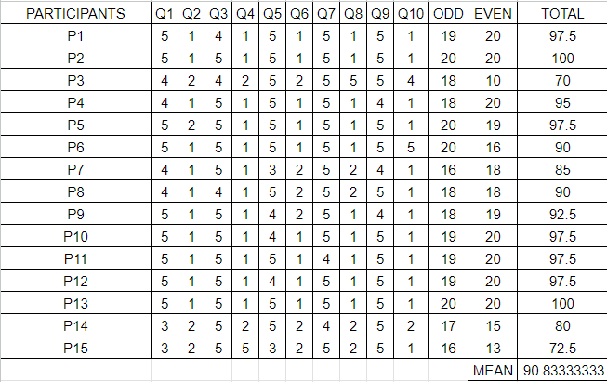

*Fig. 1. SUS Results*

As shown in the table (Fig.1), the mean calculated SUS score of the application was 90.83, ensuring that the system's usability is excellent as per the user participants. The users were also given a section in the survey to note down feedbacks or suggestions for the application to have an idea on the qualitative response of the users. These were some of the feedbacks directly quoted from the users:

* "This app is really great for people who is need in to get things out of their system. Or just to document their day to day life. I find this app very helpful for my mental health because of the journalings but also the counselling request and encouraging messages. Would probably use this every day."
* "Color theme of the app was so nice and calming! Nice features as well!"
* "I like how innovative it is to see that there are countless students who need something to rant about or journal about. When they are stressed or just wanting to put something in a journal it can be helpful because it is now in their very own phones. I found it easy to use, and having an app that can get counseling requests will make it easy for me to let out what I feel to counselors."
* "I think everything's good! I really liked the sentiment analysis."
* "Commend on the simplicity of the UI, easy to look at and navigate."

These feedbacks show the positive outlook of the users on the application and how this can help in monitoring their day-to-day emotions and activities as well as give them an easy platform to communicate and receive daily motivational messages from professionals and staff.

# **CONCLUSIONS AND FUTURE WORKS**

This study developed a mental health application where users can log their everyday journal entries and immediately gain sentiment analysis for these journals. It also gave them weekly, monthly and yearly reports on their overall moods depending on the journal entries they have made in the application. This application also gave students and OCG staff a medium to communicate daily through the motivational and supportive messages as well as allow personal communication with students and staff through the counselling requests they have sent. With this, the UPLB Muni application was able to obtain a mean SUS score of 90.83, which indicates that it has excellent usability for the users, allowing them to utilize this application easily for their needs and well-being without having to allot too much time on learning how to use the application. The features of the application and the UI itself also gained positive response and feedback from the users based on the feedback portion of the survey after they have tested the application.

# **RECOMMENDATIONS**

For future development of the application, the developer suggests allowing the application to translate Filipino journals in English first before analyzing the sentiment in order to allow a more accurate detection of mood and emotions in the journal entries. It is also suggested that the future developers add relaxation exercises the moment that they open the application, which was found to also help the mental wellness of individuals.

# **BIBLIOGRAPHY**

Akpınar, E. (2021). The effect of online learning on Tertiary Level Students’ mental health during the covid19 lockdown. *The European Journal of Social &amp; Behavioural Sciences*, *30*(1), 52–62. https://doi.org/10.15405/ejsbs.288

Ay, T. (2019, April 29). *WHO-aims report on Mental Health System in the Philippines Department of Health*. Academia.edu. <https://www.academia.edu/38969988/WHO_AIMS_REPORT_ON_MENTAL_HEALTH_SYSTEM_IN_THE_PHILIPPINES_DEPARTMENT_OF_HEALTH>

Gillis, A. S., & Barney, N. (2024, June 5). *What is sentiment analysis?: Definition from TechTarget*. Business Analytics. <https://www.techtarget.com/searchbusinessanalytics/definition/opinion-mining-sentiment-mining>

Caplan, S., Sosa Lovera, A., & Reyna Liberato, P. (2018). A feasibility study of a mental health mobile app in the Dominican Republic: The untold story. International Journal of Mental Health, 47(4), 311–345. <https://doi.org/10.1080/00207411.2018.1553486>

Copeland, W. E., McGinnis, E., Bai, Y., Adams, Z., Nardone, H., Devadanam, V., Rettew, J., & Hudziak, J. J. (2021). Impact of covid-19 pandemic on College Student Mental Health and Wellness. Journal of the American Academy of Child &amp; Adolescent Psychiatry, 60(1). <https://doi.org/10.1016/j.jaac.2020.08.466>

O’Dea, B., Han, J., Batterham, P. J., Achilles, M. R., Calear, A. L., Werner‐Seidler, A., Parker, B., Shand, F., & Christensen, H. (2020). A randomised controlled trial of a relationship‐focussed mobile phone application for improving adolescents’ mental health. Journal of Child Psychology and Psychiatry, 61(8), 899–913. <https://doi.org/10.1111/jcpp.13294>

Gál, É., Ștefan, S., & Cristea, I. A. (2021). The efficacy of mindfulness meditation apps in enhancing users’ well-being and mental health related outcomes: A meta-analysis of randomized controlled trials. Journal of Affective Disorders, 279, 131–142. <https://doi.org/10.1016/j.jad.2020.09.134>

Götzl, C., Hiller, S., Rauschenberg, C., Schick, A., Fechtelpeter, J., Fischer Abaigar, U., Koppe, G., Durstewitz, D., Reininghaus, U., & Krumm, S. (2022). Artificial Intelligence-informed mobile mental health apps for Young People: A mixed-methods approach on users’ and stakeholders’ perspectives. Child and Adolescent Psychiatry and Mental Health, 16(1). <https://doi.org/10.1186/s13034-022-00522-6>

Hechanova-Alampay, Ma. R., Angeles, P. L., Tuliao, A., Hilario, E., Pagente, A. F., & Narra, C. V. (2022). The development and pilot evaluation of a mental health mobile app in the Philippines. Mental Health and Social Inclusion. <https://doi.org/10.1108/mhsi-04-2022-0024>

Labrague, L. J., De los Santos, J. A., & Falguera, C. C. (2021). Social and emotional loneliness among college students during the COVID‐19 pandemic: The predictive role of coping behaviors, social support, and personal resilience. Perspectives in Psychiatric Care, 57(4), 1578–1584. <https://doi.org/10.1111/ppc.12721>

Patacsil, F. F., Malicdem, A. R., & Fernandez, P. L. (2015). Estimating Filipino isps customer satisfaction using sentiment analysis. Computer Science and Information Technology, 3(1), 8–13. <https://doi.org/10.13189/csit.2015.030102>

Santomauro, D. F., Mantilla Herrera, A. M., Shadid, J., Zheng, P., Ashbaugh, C., Pigott, D. M., Abbafati, C., Adolph, C., Amlag, J. O., Aravkin, A. Y., Bang-Jensen, B. L., Bertolacci, G. J., Bloom, S. S., Castellano, R., Castro, E., Chakrabarti, S., Chattopadhyay, J., Cogen, R. M., Collins, J. K., … Ferrari, A. J. (2021). Global prevalence and burden of depressive and anxiety disorders in 204 countries and territories in 2020 due to the COVID-19 pandemic. The Lancet, 398(10312), 1700–1712. <https://doi.org/10.1016/s0140-6736(21)02143-7>

Sukmawati, I., Ardi, Z., Ifdil, I., & Zikra, Z. (2019). Development and validation of acceptability of Mental-Health Mobile App Survey (AMMS) for Android-Based Online Counseling Service assessment. Journal of Physics: Conference Series, 1339(1), 012124. <https://doi.org/10.1088/1742-6596/1339/1/012124>

Thornton, L. K., & Kay-Lambkin, F. J. (2018). Specific features of current and Emerging Mobile Health Apps: User views among people with and without mental health problems. mHealth, 4, 56–56. <https://doi.org/10.21037/mhealth.2018.11.04>

Wang, X., Markert, C., & Sasangohar, F. (2021). Investigating popular mental health mobile application downloads and activity during the COVID-19 pandemic. Human Factors: The Journal of the Human Factors and Ergonomics Society, 65(1), 50–61. <https://doi.org/10.1177/0018720821998110>

What is react native? Complex Guide for 2024. Digital Acceleration Company. (n.d.). <https://www.netguru.com/glossary/react-native>

Bhat, A. (2023, August 14). System usability scale: What it is, calculation + usage. QuestionPro. <https://www.questionpro.com/blog/system-usability-scale/>

# **APPENDIX**

*Fig. 1. Login Page* *Fig. 2. Supportive Messages Page*

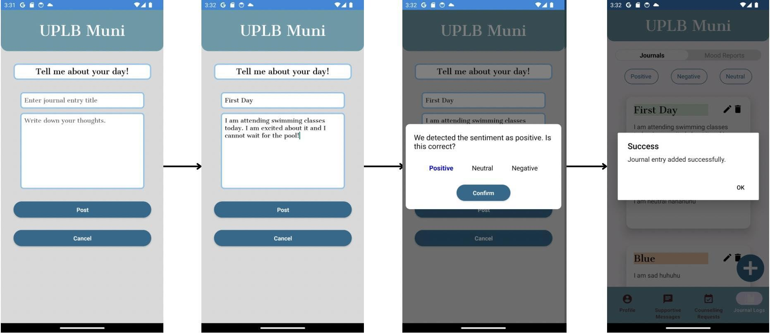

*Fig. 3. Add Journal Entries*

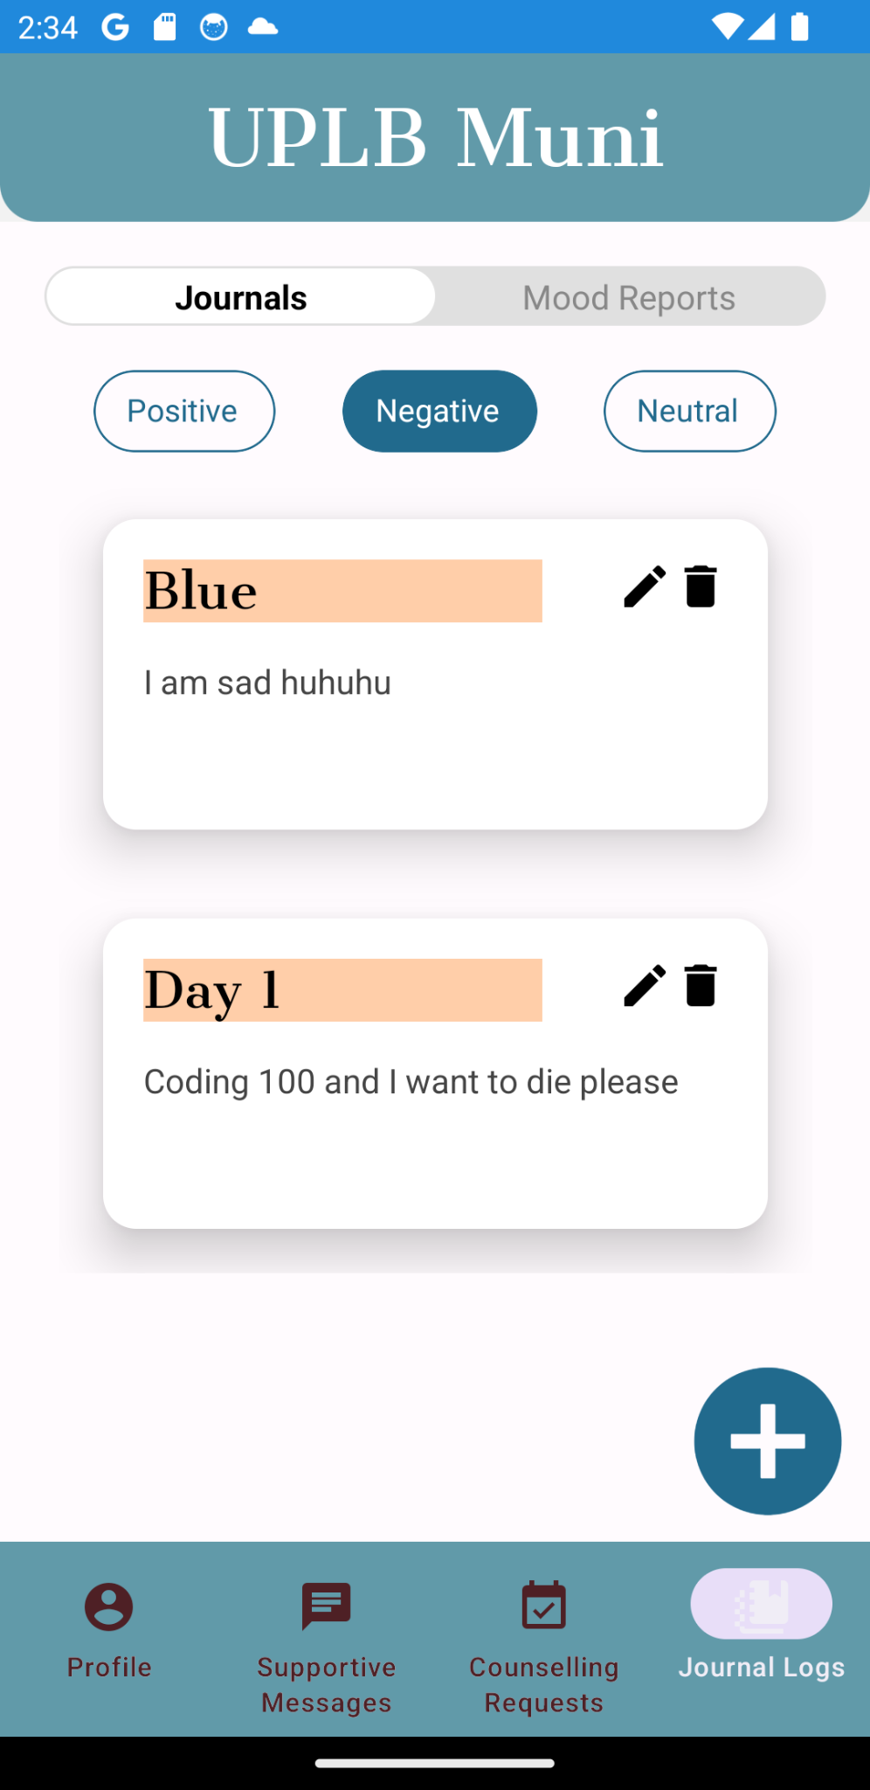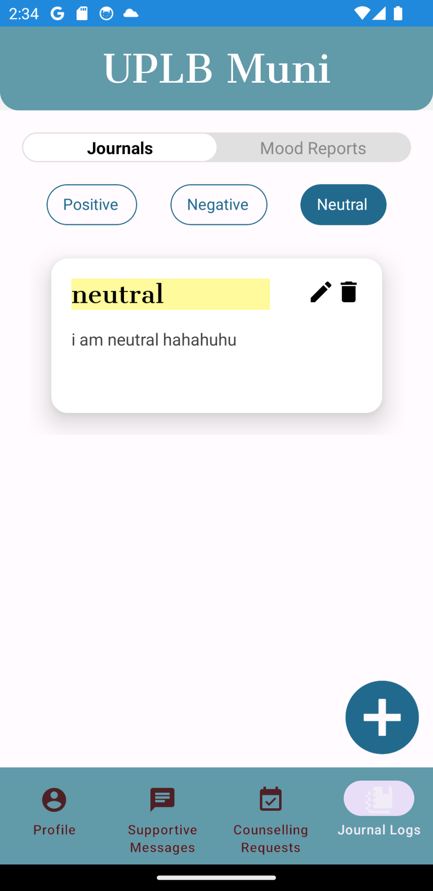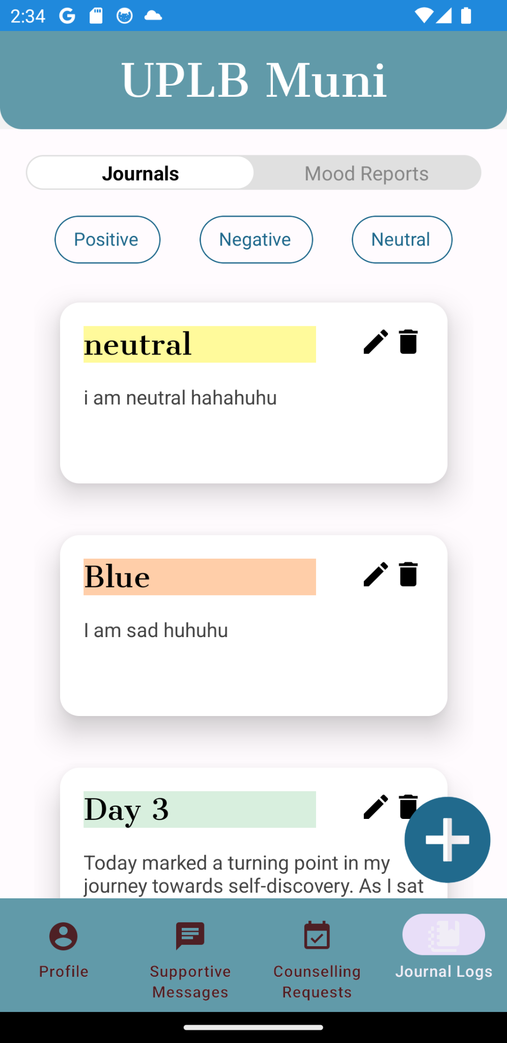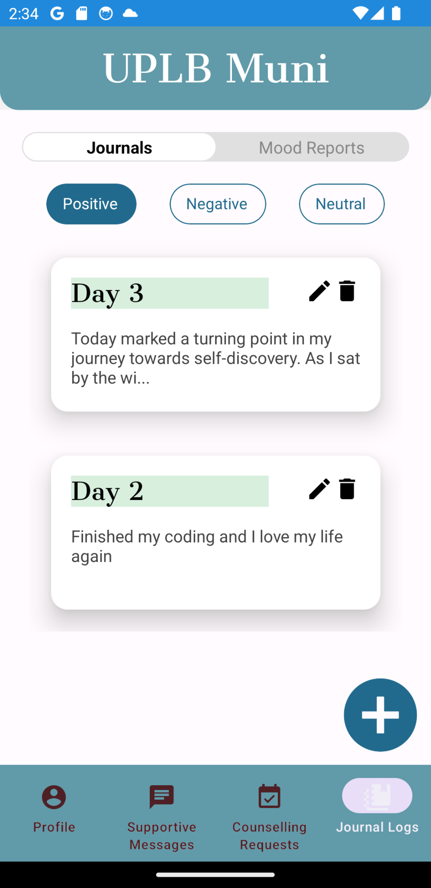

*Fig. 4. Journal Entries*

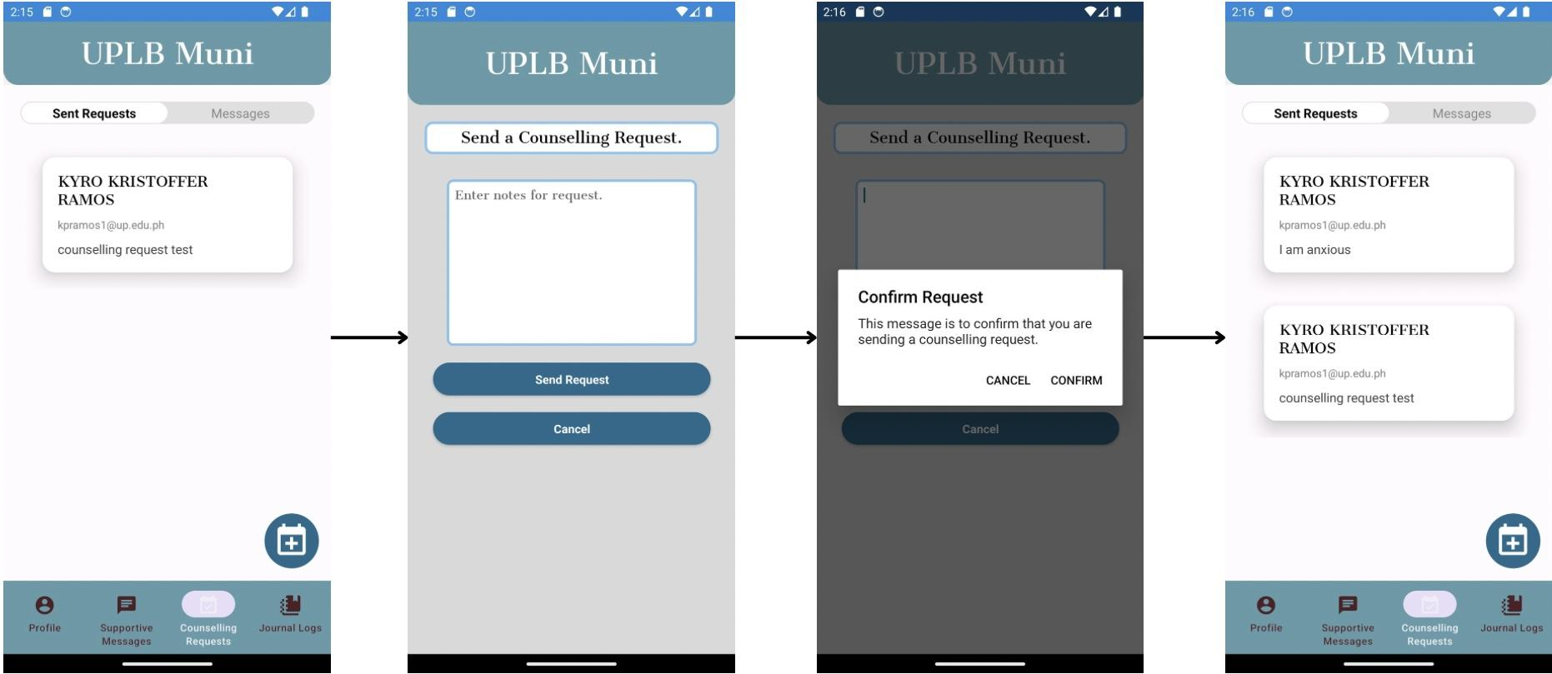

*Fig. 5. Send Counselling Request*

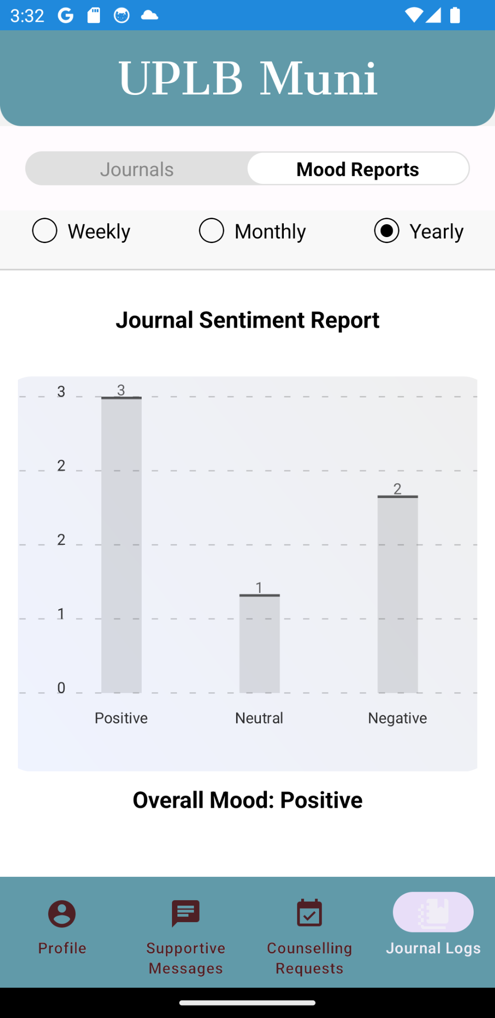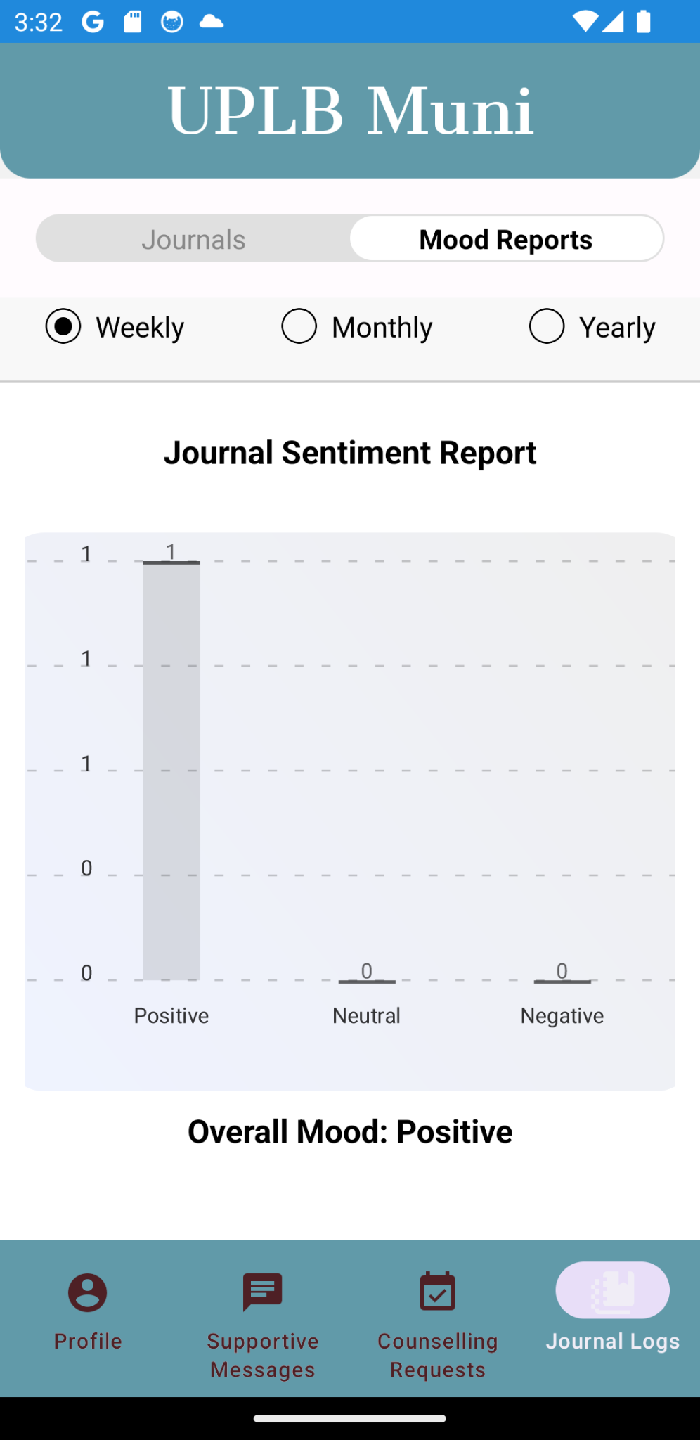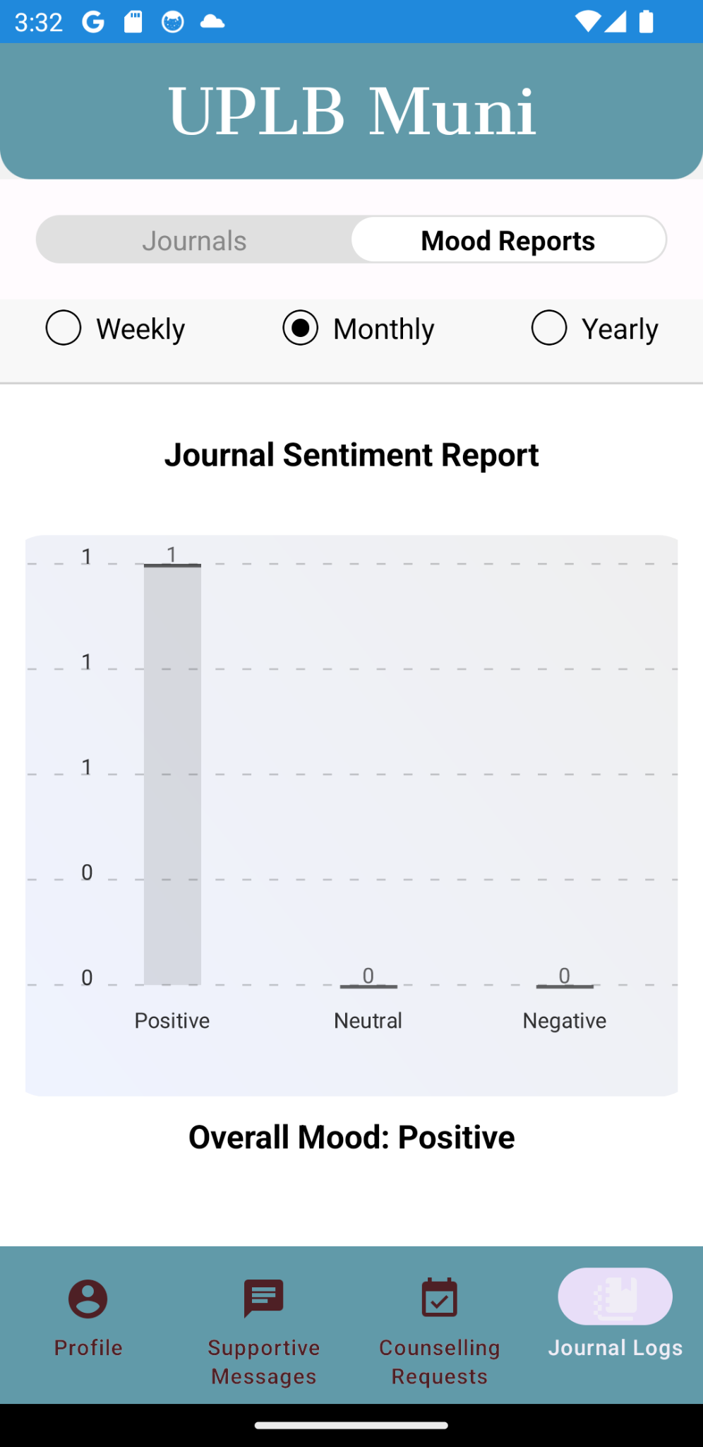

*Fig. 6. Mood Reports*

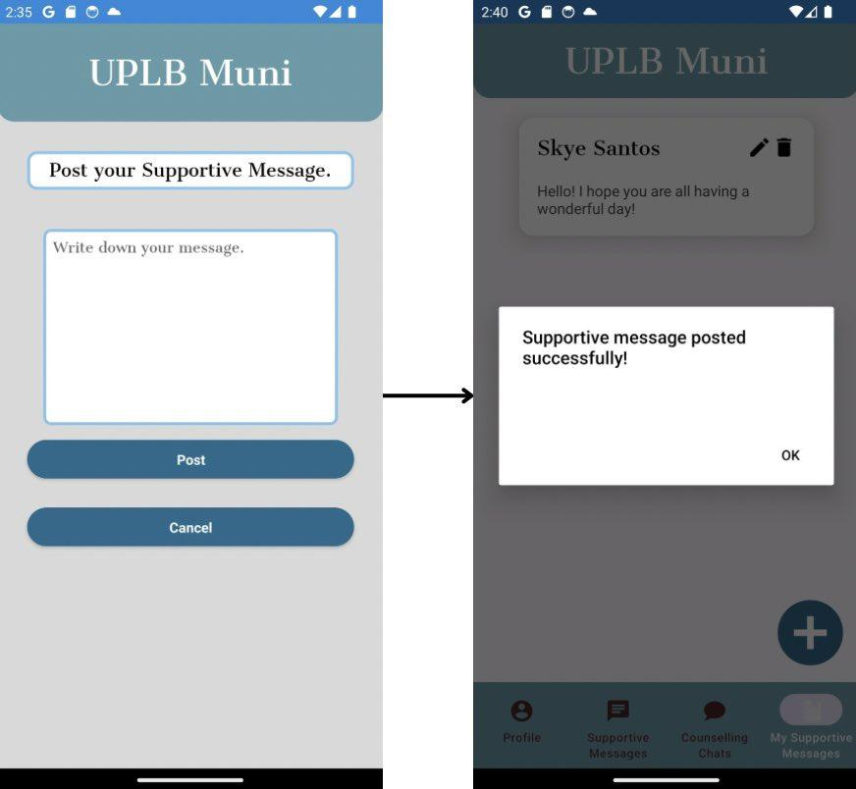

*Fig. 8. Post Supportive Messages*

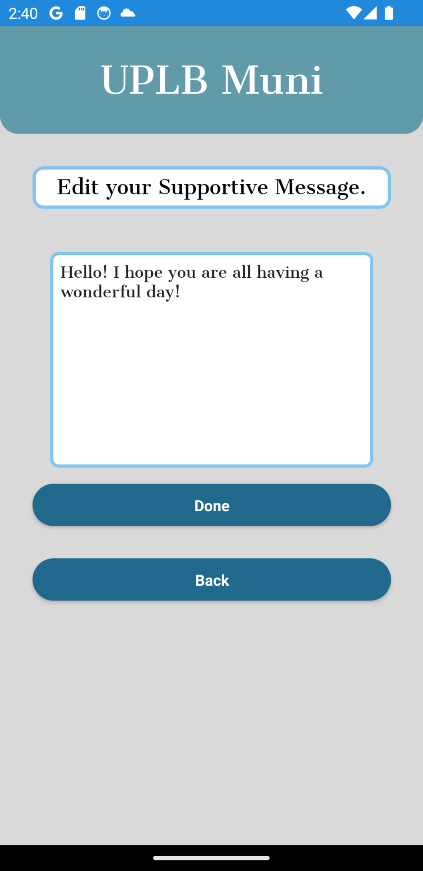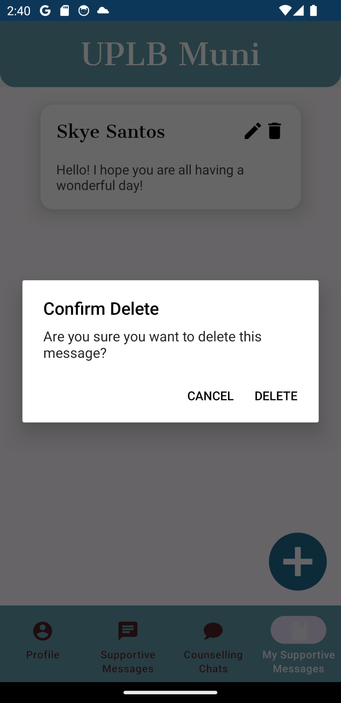

*Fig. 9. Edit Message Fig. 10. Delete Message*

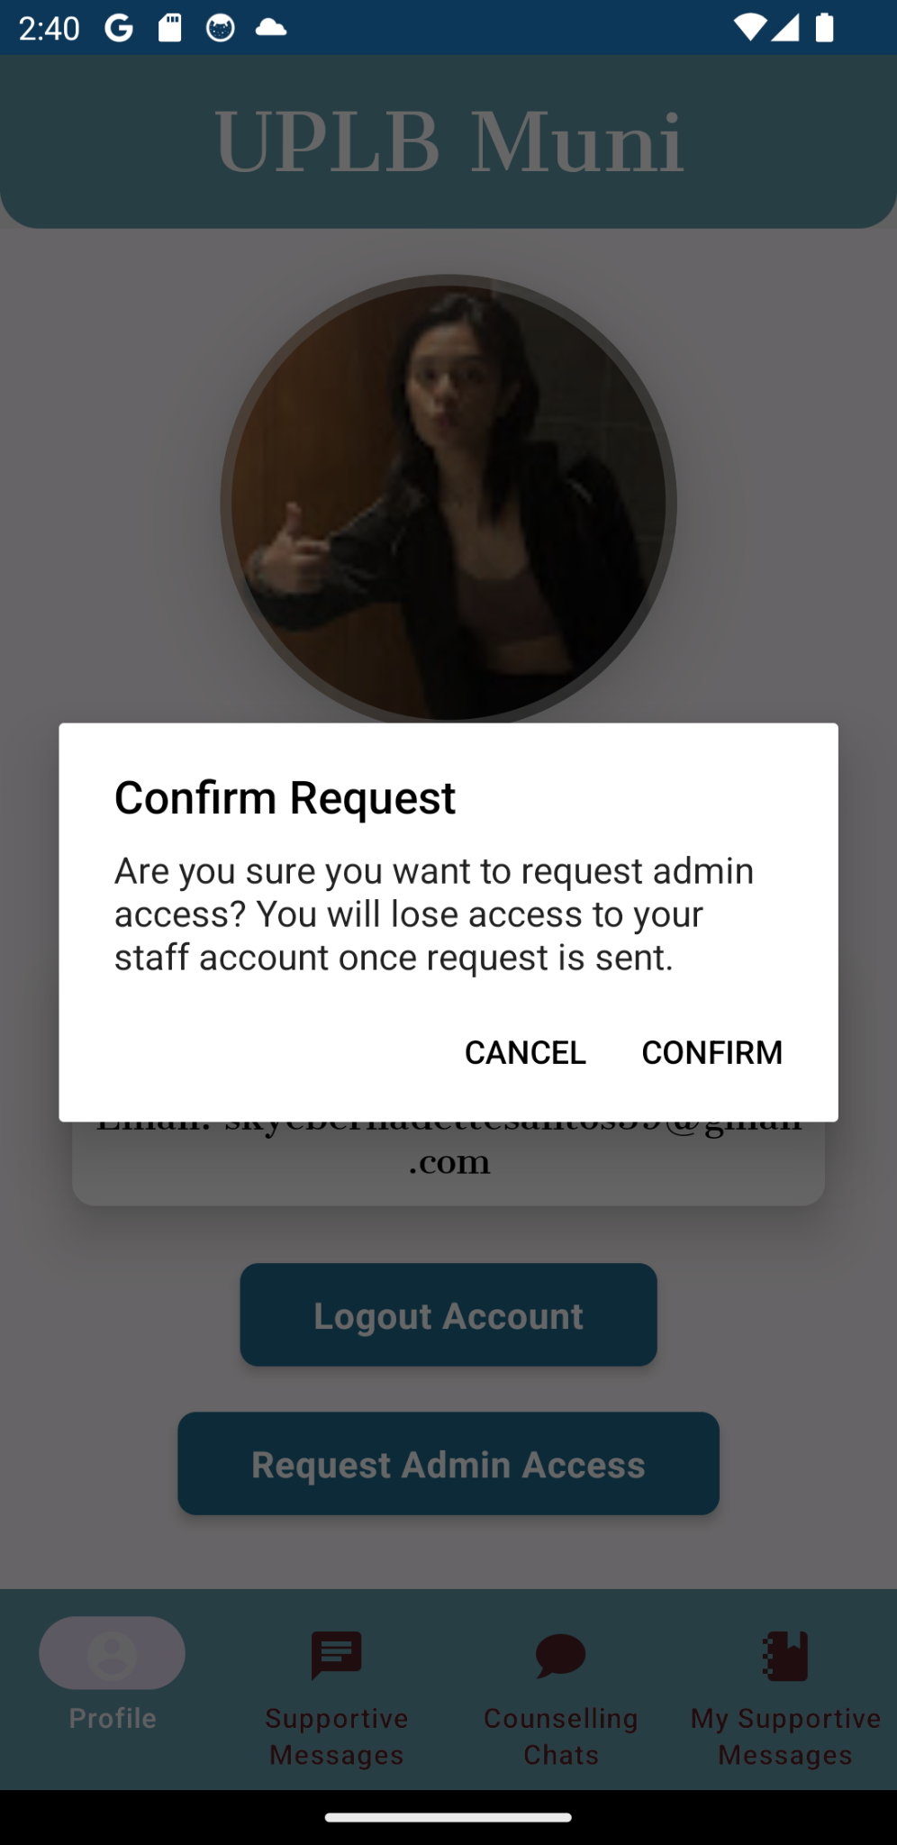

*Fig.11. Request Access*

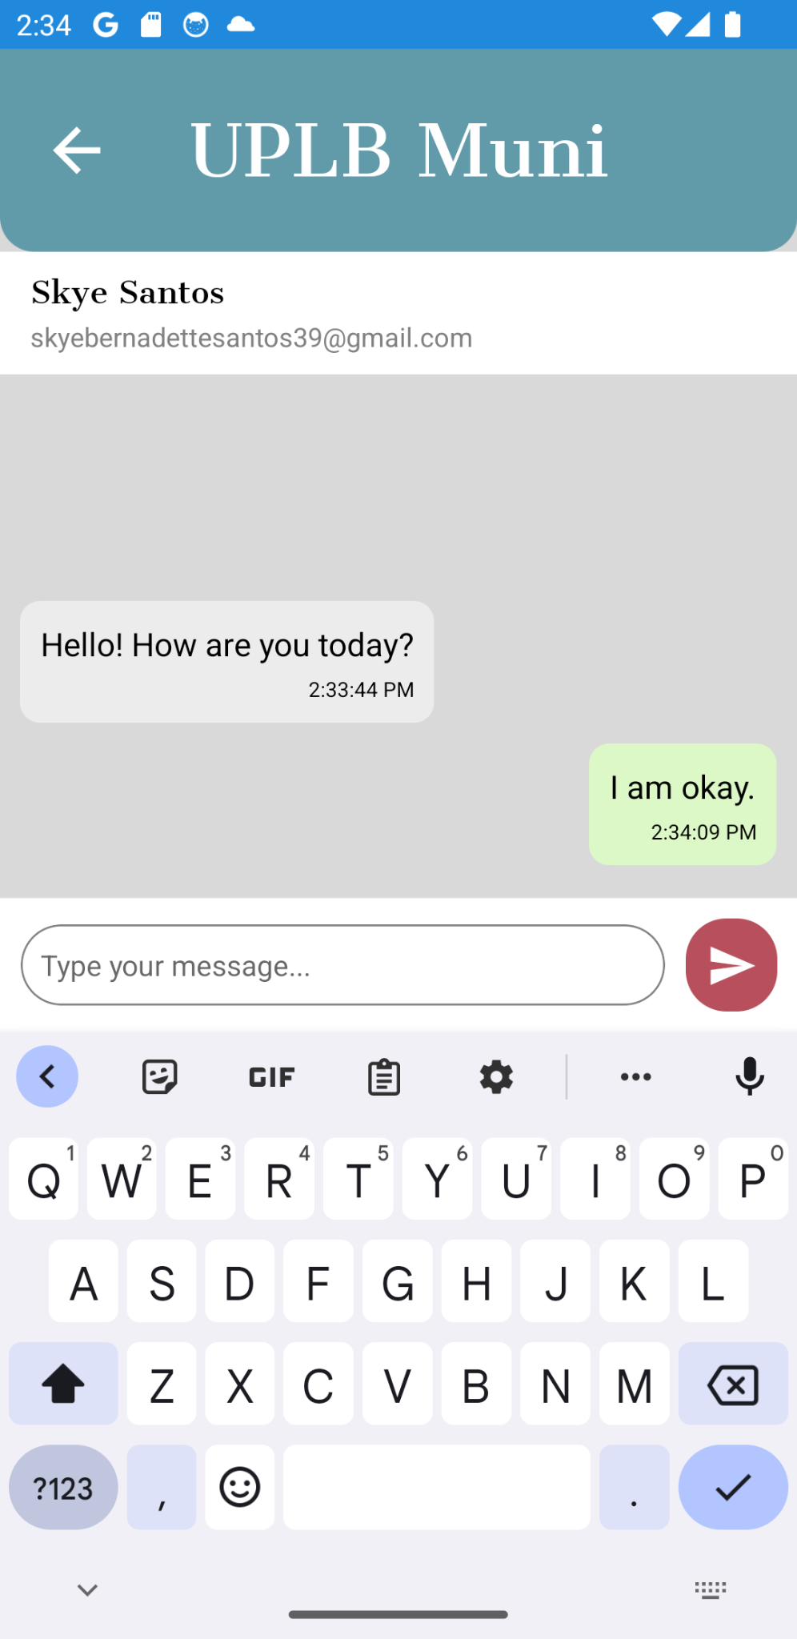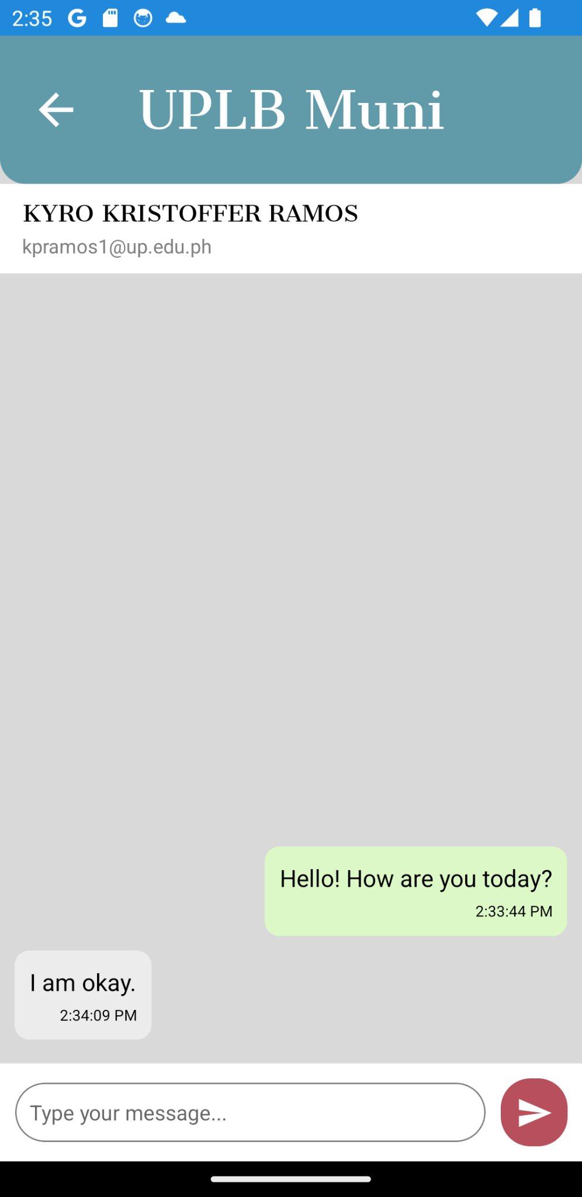

*Fig. 12. Chat Feature*

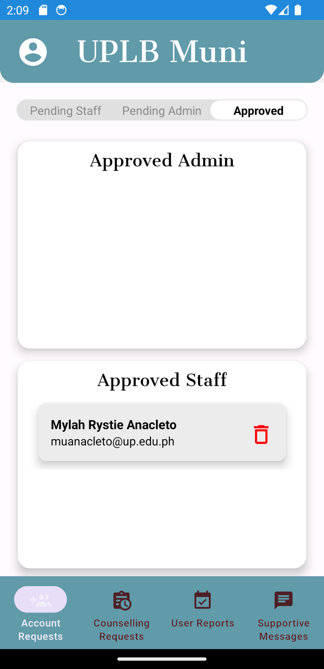

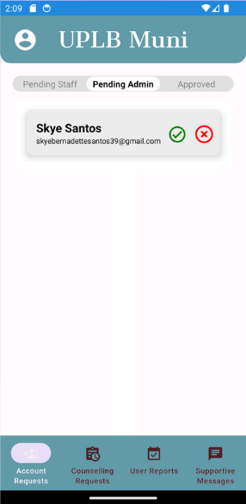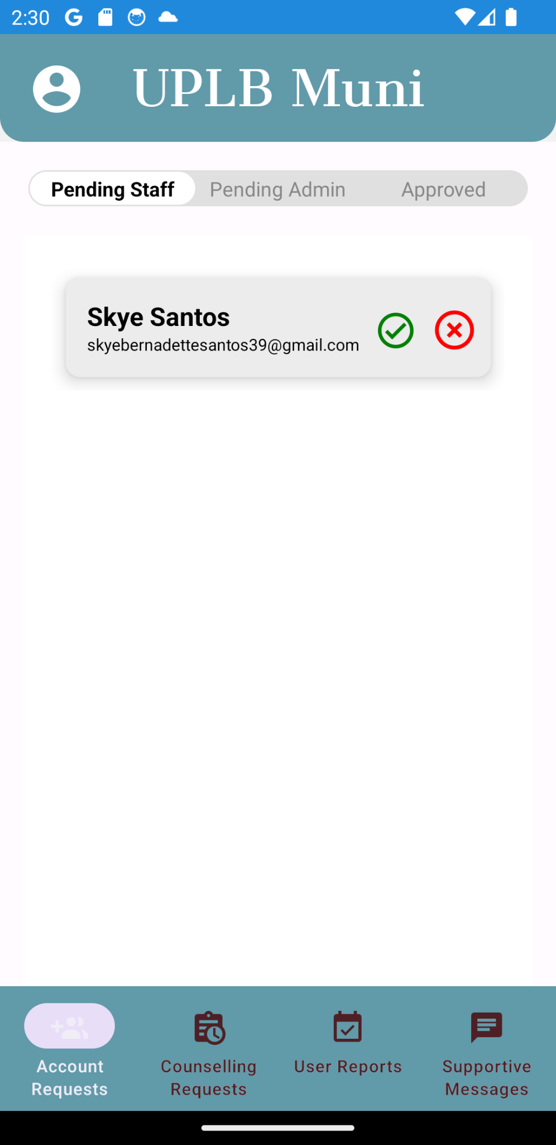

*Fig. 13. Admin View*

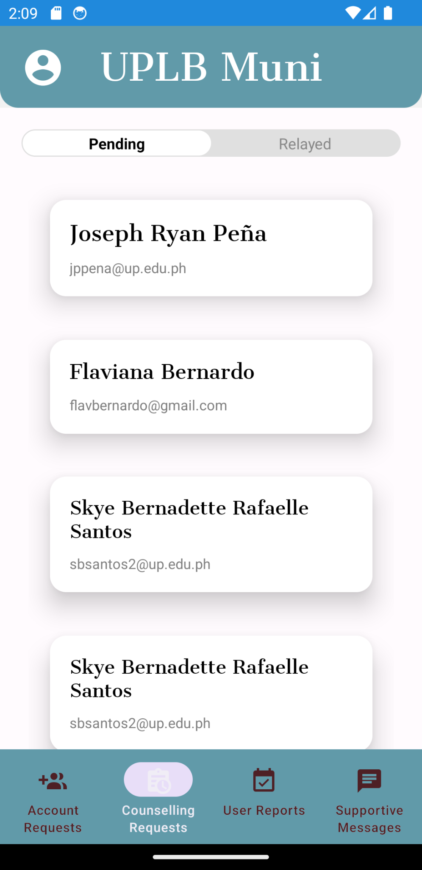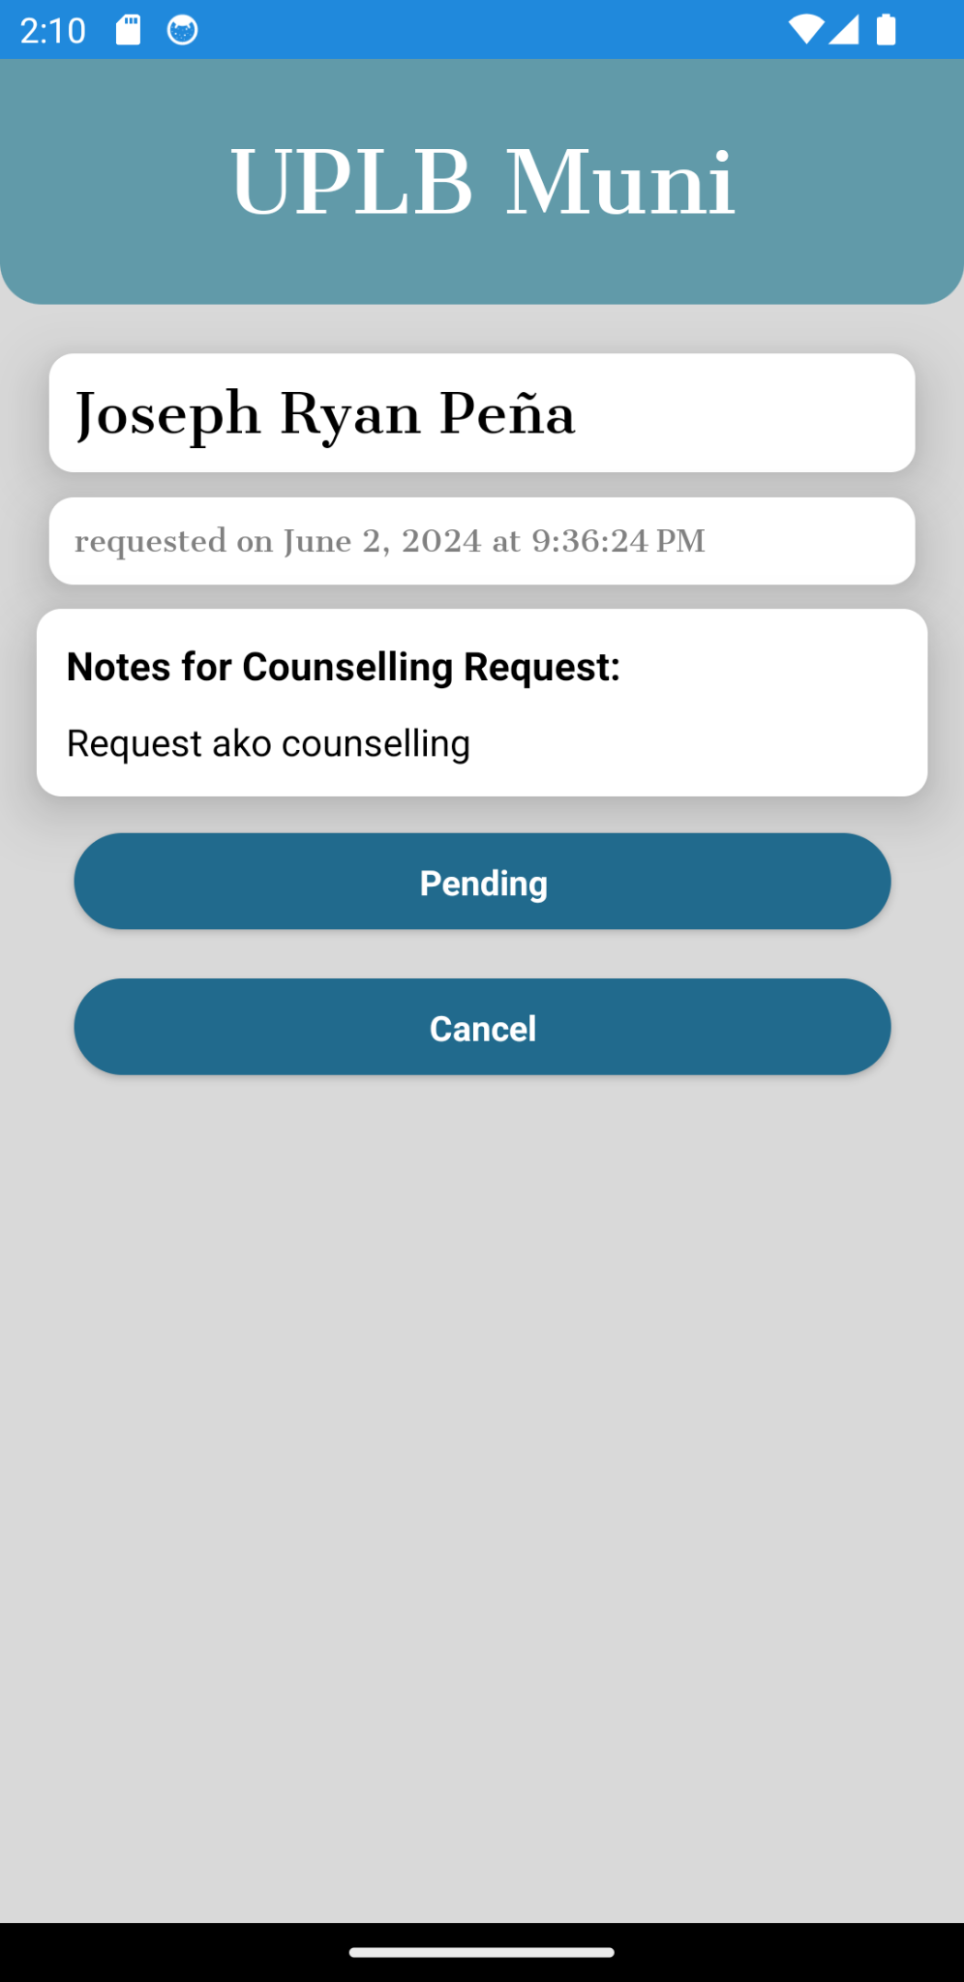

*Fig. 14. Pending Counselling Requests*

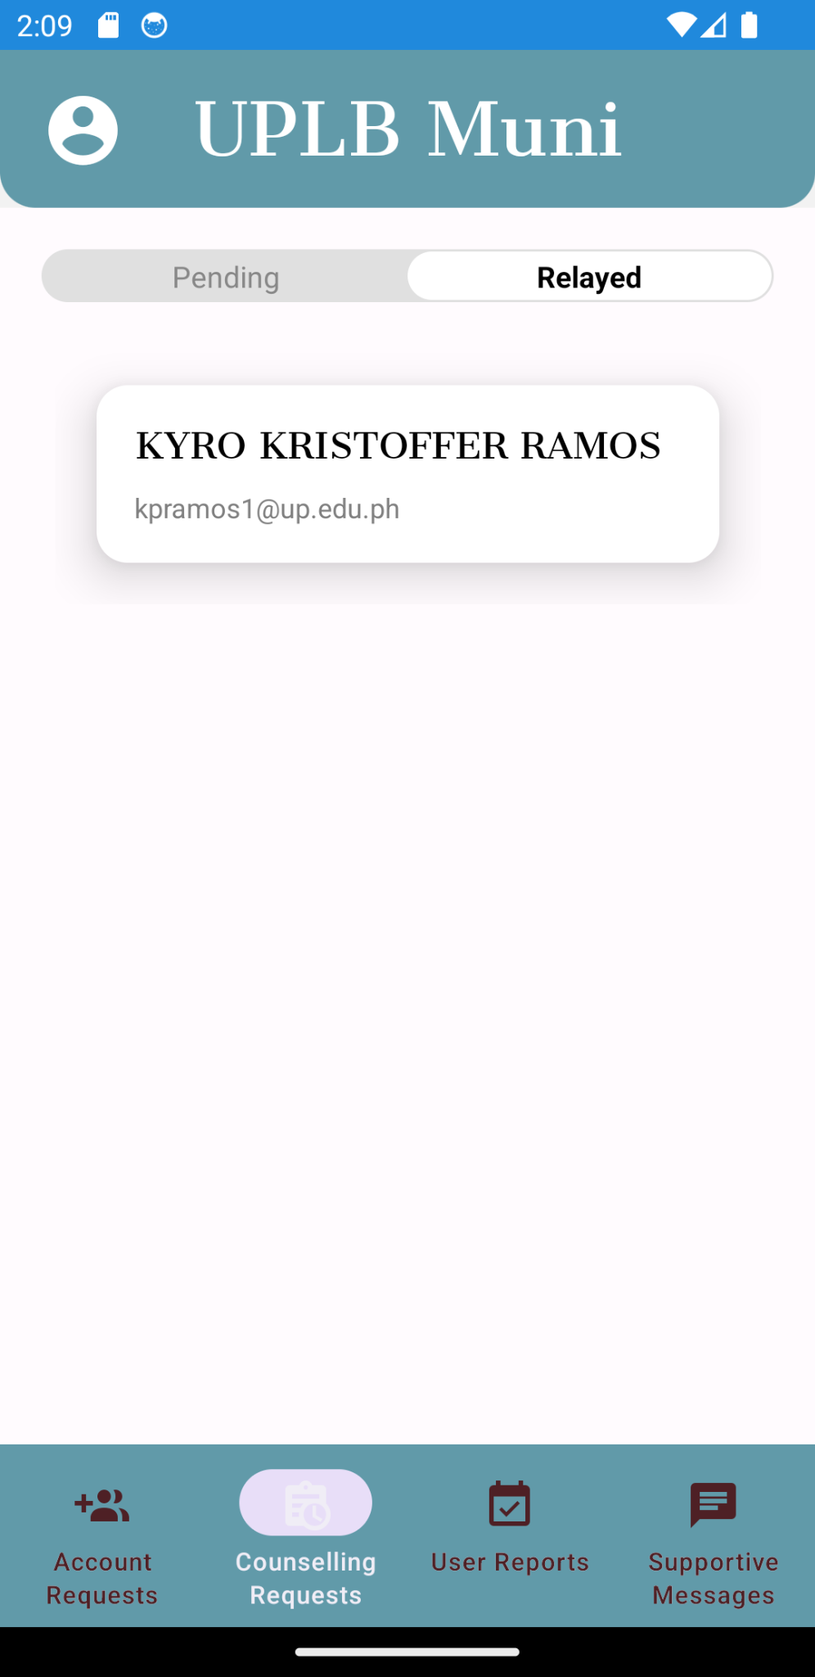

*Fig. 15. Relayed Counselling*

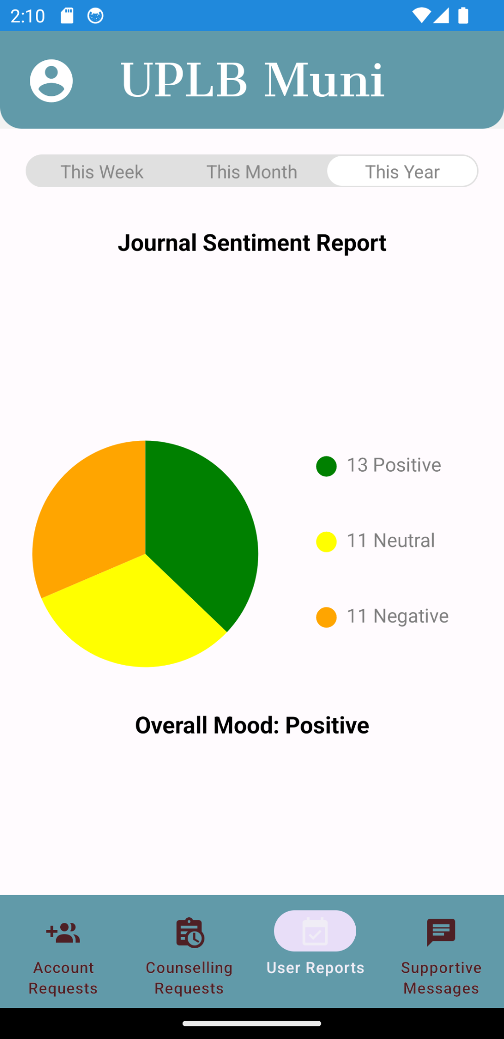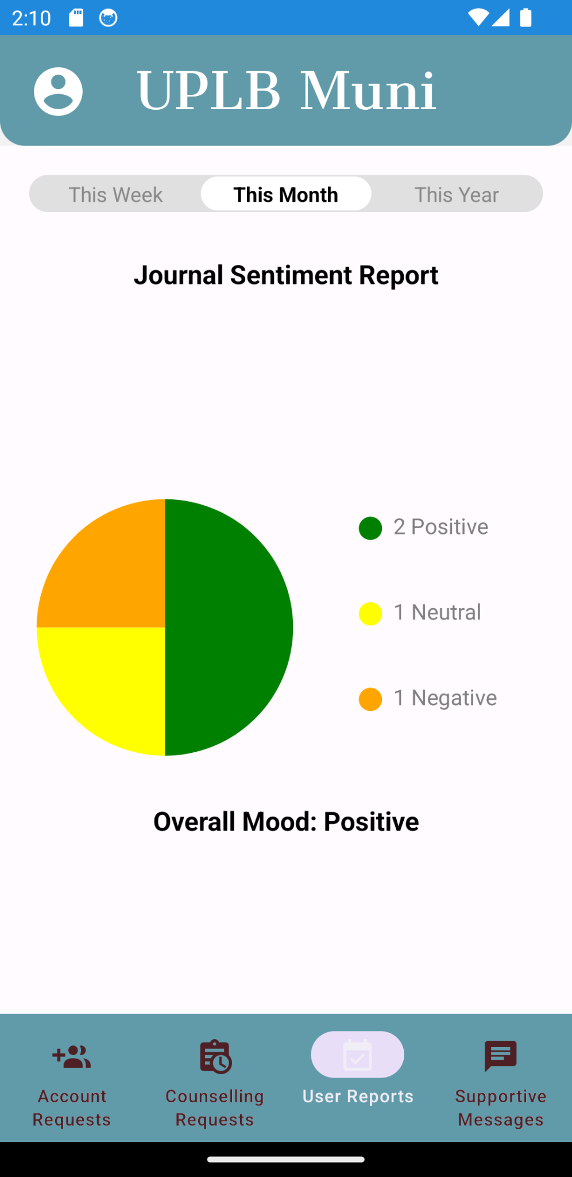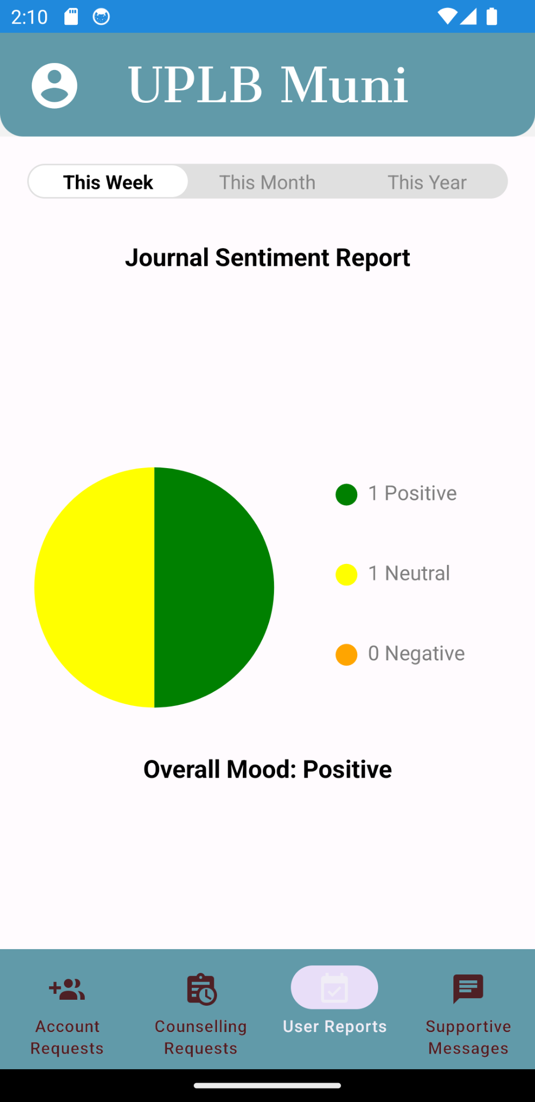

*Fig. 16. Overall Mood Reports*